Stage 1 – Learning Framework – Week 5
You will need access to a digital device and help from a parent/carer to complete the following activities. If you do not have a device, simply follow the instructions in the framework below. Log onto Class Dojo using your student account to check what activities your teacher has posted for the day. Complete your work in your homework book, digitally or on paper. Submit a photo on Class Dojo to be marked as ‘present’ on the roll. If you have any issues, please contact your teacher through Class Dojo.
 | Monday | Tuesday | Wednesday | Thursday | Friday
Task | Make your bed today. | Make sure you clean up after yourself, all day! | Clean your room. | Help clean or put away the dishes. | Help fold the washing again!
Morning | English  Spelling and Phonics  Write down your spelling words and brainstorm words with the sounds of the week.  Year 1: oa and sc  Year 2: Bossy e-i and oo (moon)  Sentence Work  Unjumble this sentence about school and add in the correct punctuation.  my subject at is maths favourite school  Reading  Read a book of your choice at least 10mins. Then complete the following activity:  What are 10 words you would use to describe one of the characters from the story? | English  Spelling and Phonics  Wacky Words: On a sheet of paper, write your spelling words in different directions, filling up the whole sheet. Use different colours and types of writing for each word.  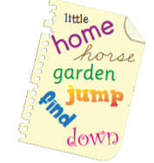  Sentence Work  Unjumble this sentence about school and add in the correct punctuation.  At my best are Bob and James school friends  Reading  Read a book of your choice at least 10mins. Then complete the following activity:  What part of the story did you find most boring? Why? | English  Spelling and Phonics  Spelling Pictures: Draw a picture of each of your spelling words.  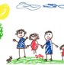  Writing  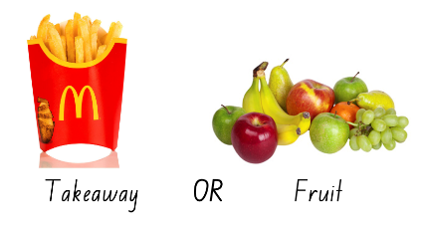  Takeaway or fruit. Which do you think is better? Why?  Year 1: choose either takeaway or fruit and write three reasons why you think it is better  Year 2: choose either takeaway or fruit and write five reasons why you think it is better | English  Spelling and Phonics  Spelling Stories: Write a story using as many of your spelling words as you can.  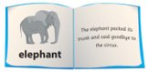  Reading  Practise reading the passage ’Fred’s New Friend. Practise reading it 2 or 3 times and see if your reading improves.  Writing  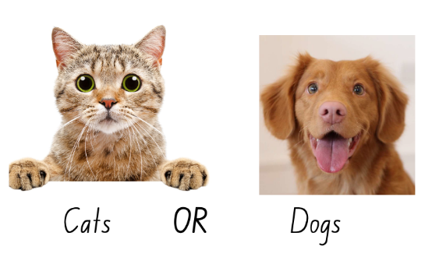  Cats or dogs. Which do you think is better? Why?  Year 1: choose either cats or dogs and write three reasons why you think it is better  Year 2: choose either cats or dogs and write five reasons why you think it is better | English  Spelling and Phonics  Back to Front: Write your spelling words forwards and then backwards.  Reading  Practise reading the passage ’Fred’s New Friend. Practise reading it 2 or 3 times and see if your reading improves. Have a go at answering the quick questions  Writing  Write an imaginative story based on the Friday picture.  Remember to include:  - Orientation (characters and setting)  - Complication (the problem)  - Resolution (how the problem is solved)
Break | Break | Break | Break | Break | Break
Middle | Mathematics – Addition  Look at the Monday maths worksheet. Complete the warm up and then complete the task.  Today, we will learn how to add numbers using jump strategy on an empty number line. | Mathematics - Addition  Look at the Tuesday maths worksheet. Complete the warm up and then complete the task.  EXTENSION: Solve the questions using two strategies. | Mathematics - Addition  Look at the Wednesday maths worksheet. Complete the warm up and then complete the task. | Mathematics – Data  In stage 1, students learn about gathering and recording information and then presenting it in graphs.  Students have learnt how to tally this year and will now work on a picture graph today.  Complete Australian Animal – Count and graph worksheet.  Extension: Which animal is shown the most? Which animal is shown the least? | Mathematics - Data  Complete the Minibeasts worksheet. Write some sentences about the graph. For example, you could write about which minibeast was shown the least, which ones had the same amount, etc.
Break | Break | Break | Break | Break | Break
Afternoon | PE  Catching | Science  Investigating water  Most of the water on Earth is salty water in our oceans and seas. Only a tiny amount of the Earth’s water is fresh water. Most living things need fresh water to survive, it is an essential resource. Desalination plants are built to turn salt water into freshwater.  Answer the questions below in your books:  - What living things need fresh water to survive?  - We know water comes from oceans and seas. Where else does water come from?  Experiment- Follow the procedure (next page) on how to turn salt water into freshwater. Draw and label a diagram of your experiment and write what happened. | History  Telling the Story  Look at the image on the History resource and discuss:  - What stories does the Aboriginal painting tell?  - Can songs tell a story?  - What movies to you know that tell an historical story?  - Can you think of any other ways stories are told?  Look at the past pictures of MDPS in the History resource. Discuss what stories do the pictures tell about MDPS from the past and how have things changed?  You are going to be a local historian for your area and tell a story about your school. You will do this by drawing a picture of the frontage of MDPS on a blank piece of paper. Make your picture as realistic as you can. An example picture of the frontage of the school is found in the History resource section for you to see and draw. | Drama  The Three Little Pigs Reader’s Theatre  Choose a character from 'The Three Little Pigs' Reader's Theatre script for you and each member of your family (you may need to be more than 1 character)  Act out the story, reading from the script. Make sure to use actions and voices your character would use.  You may like to build a house made from objects in your home. Some objects you could use are blankets, sheets, pillows, chairs, a table, boxes, or anything else you choose.  Act out the story using your special house. | PE  Catch the magical creatures!

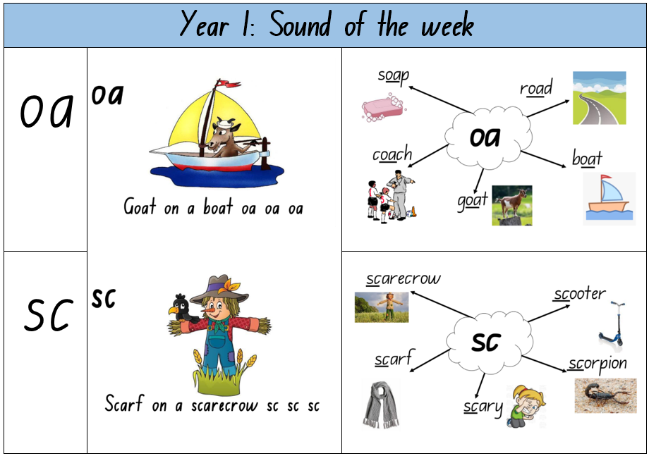
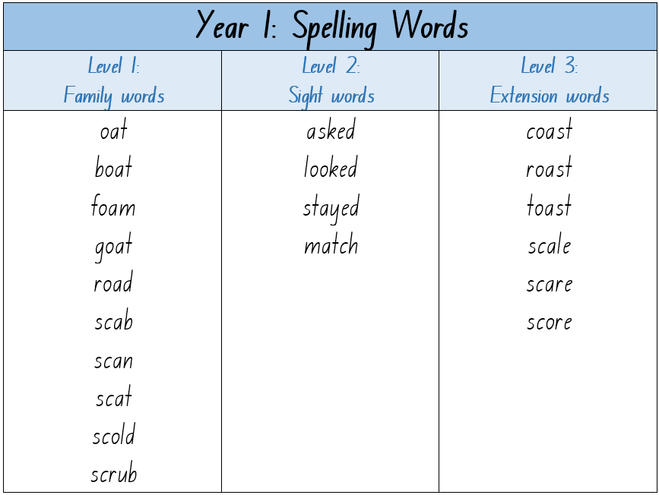
SPELLING:

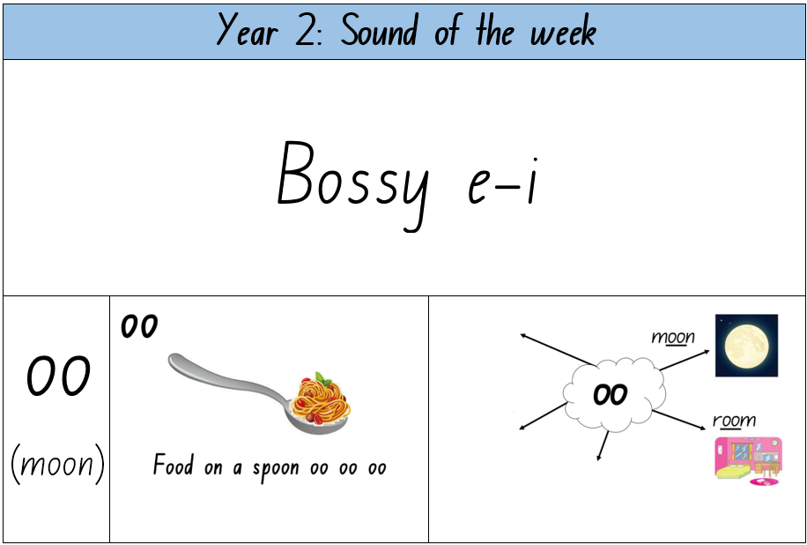
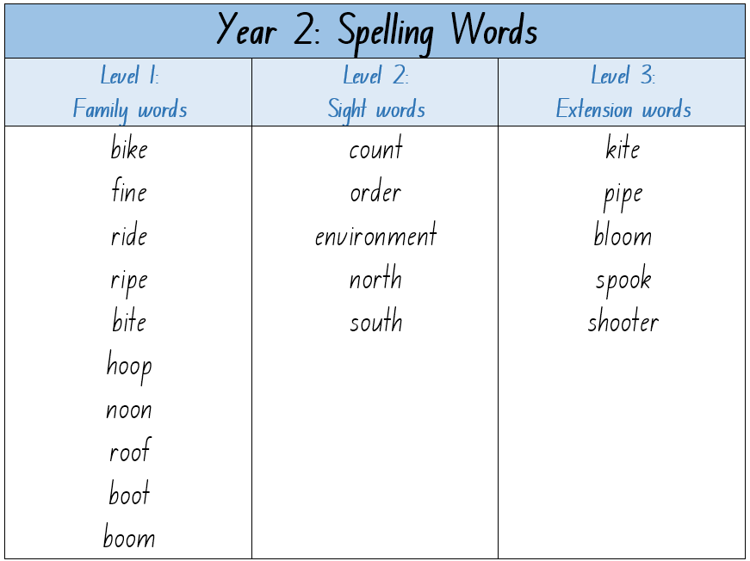

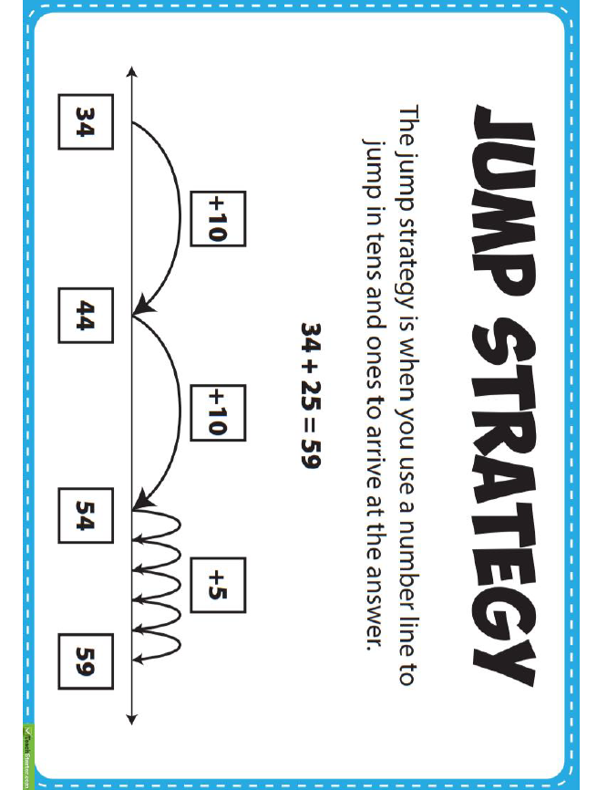
MONDAY – MATHS

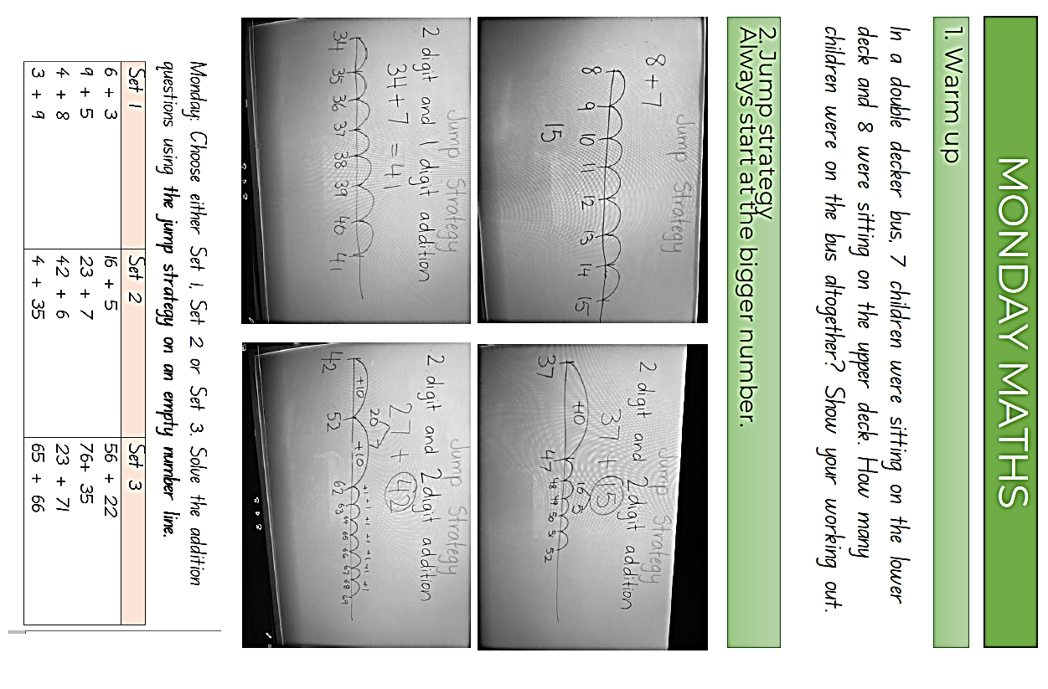

MONDAY – PE
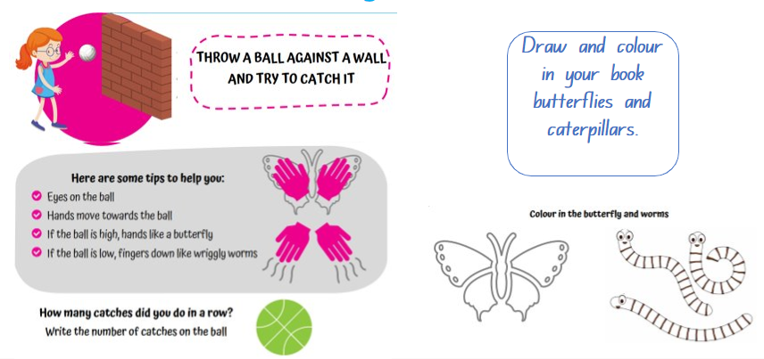

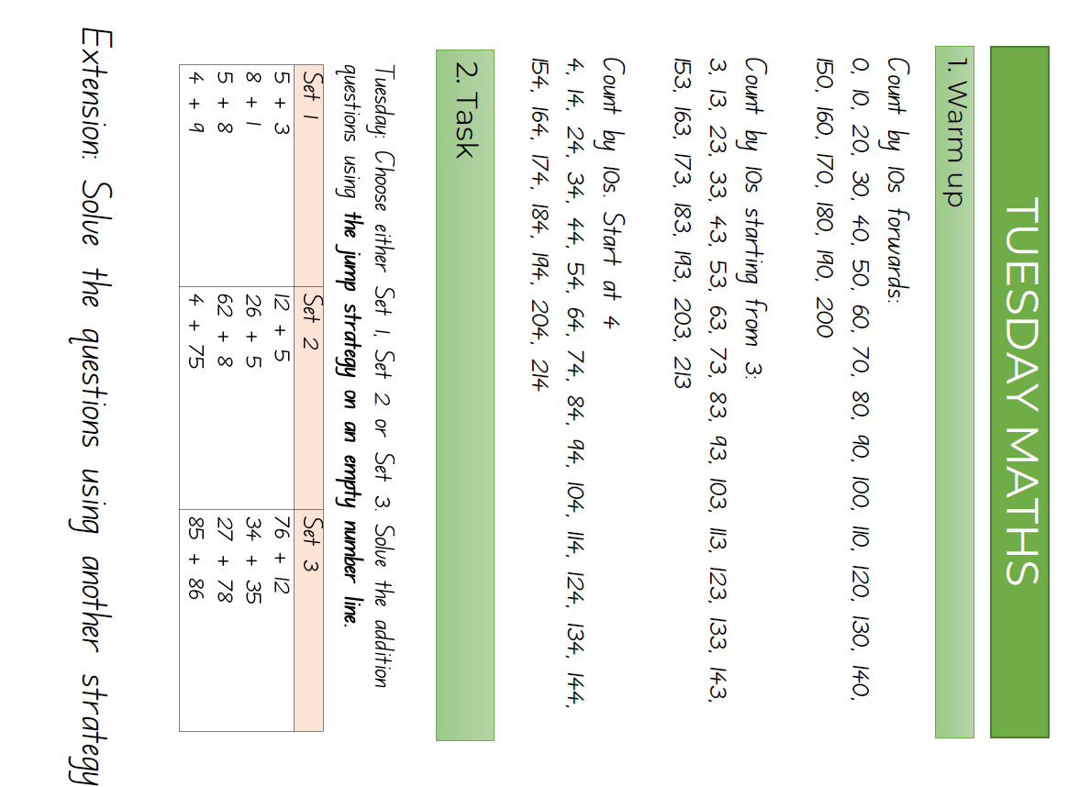
TUESDAY – MATHS

TUESDAY – SCIENCE
Experiment materials: 5 large bowl/container, 5 small bowl/cup, warm fresh water, 5 tablespoons, salt, cling wrap, some pebbles, a sunny spot
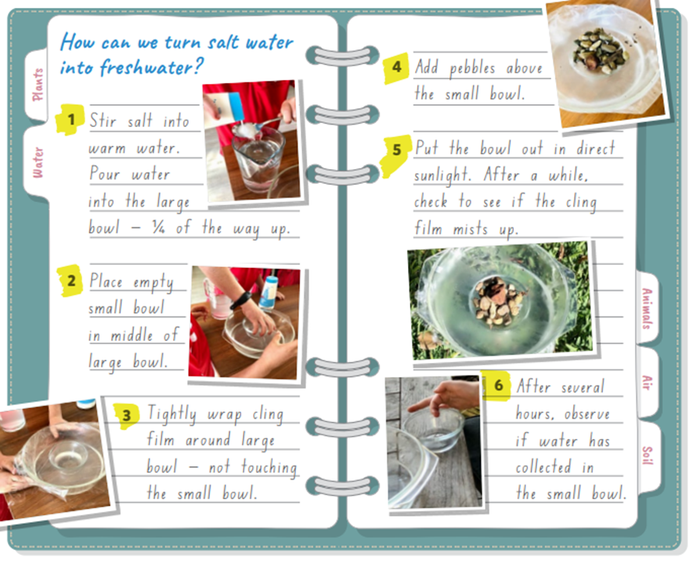

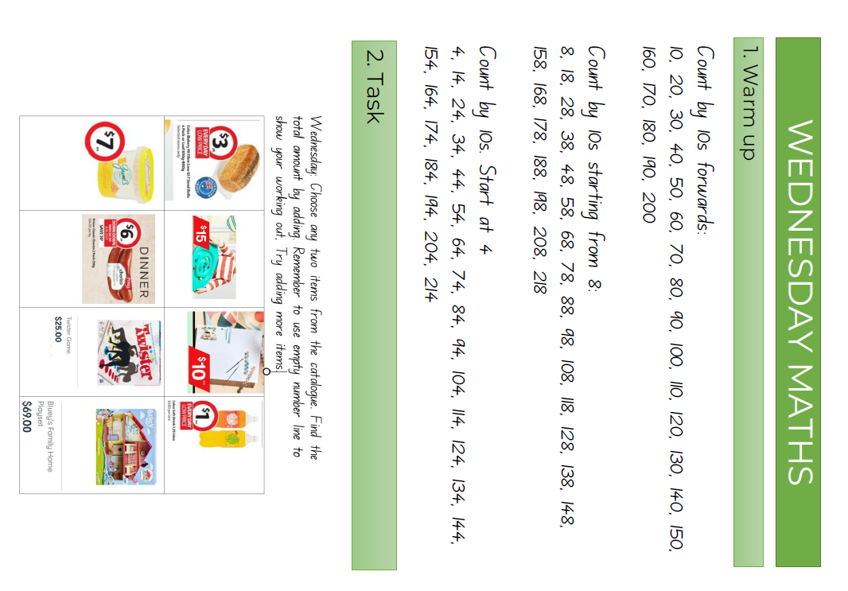
WEDNESDAY - MATHS

WEDNESDAY - HISTORY
Discuss the questions on the images with your parents
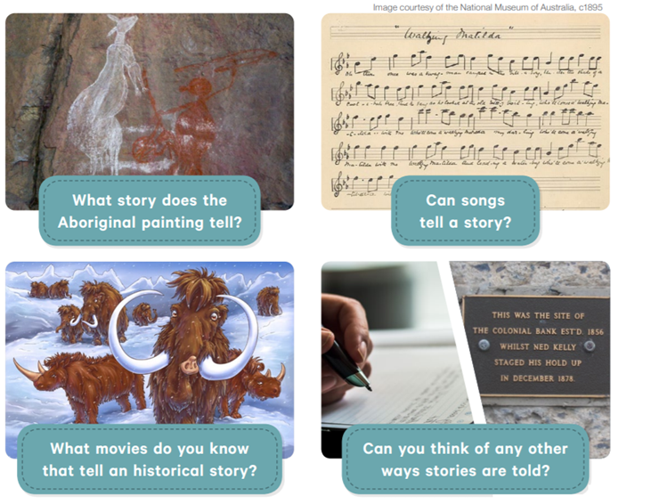

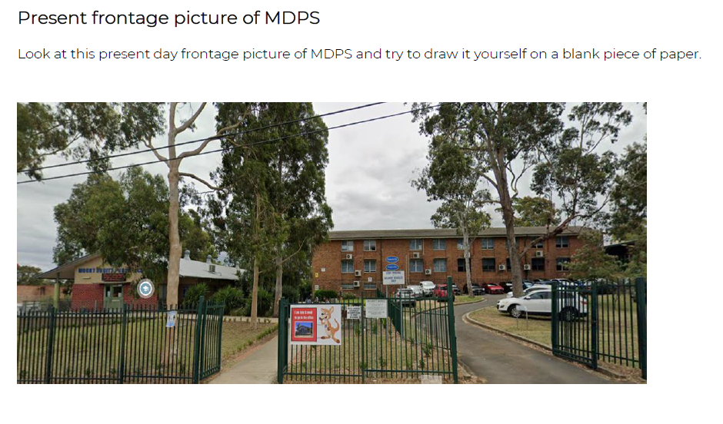
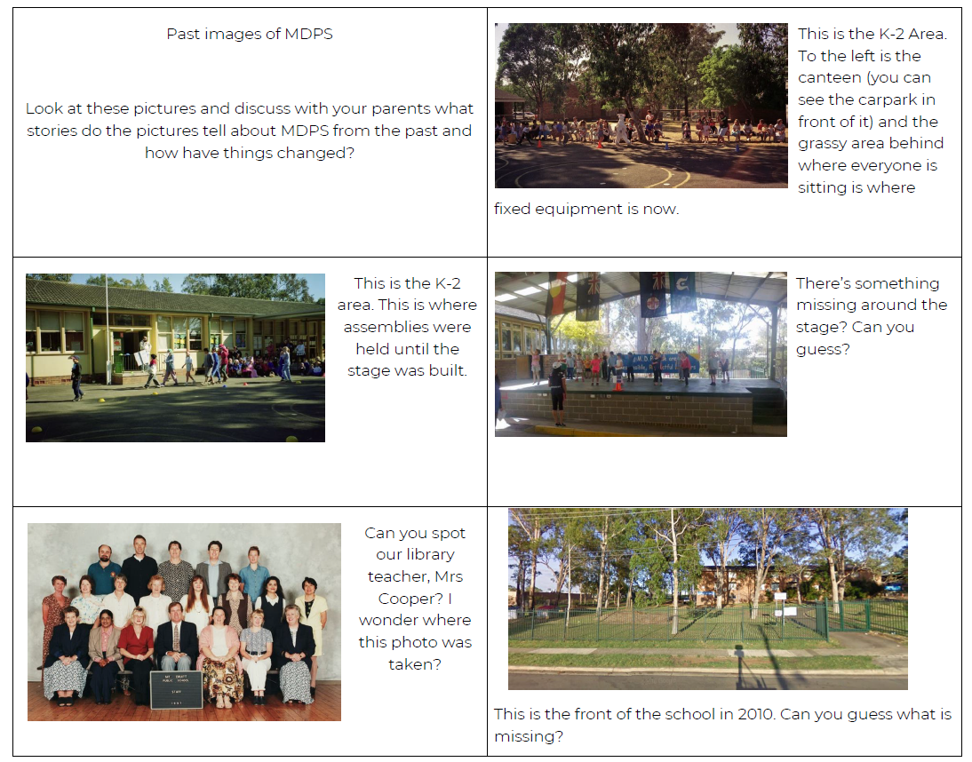

THURSDAY AND FRIDAY – READING
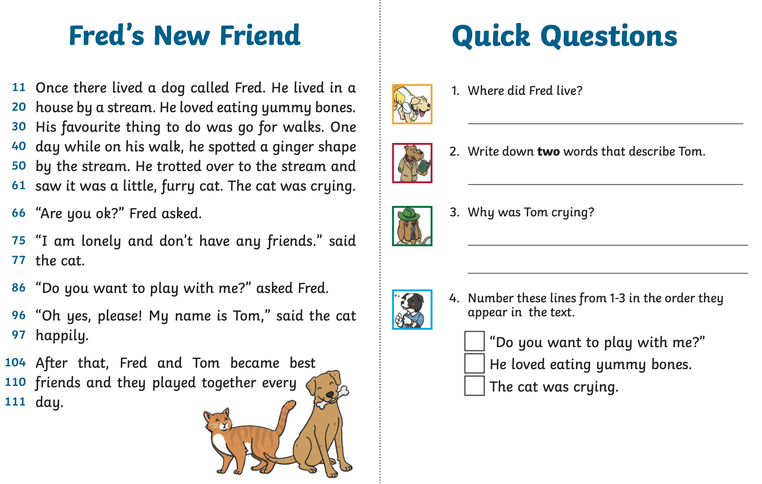

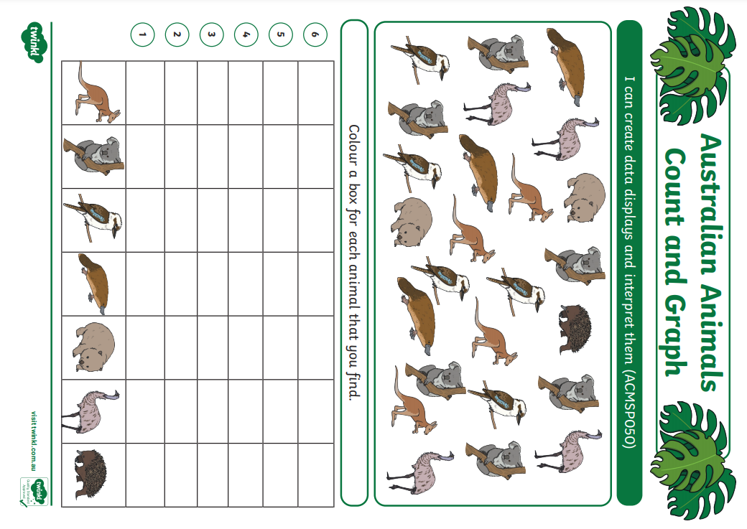
THURSDAY - MATHS

THURSDAY – DRAMA

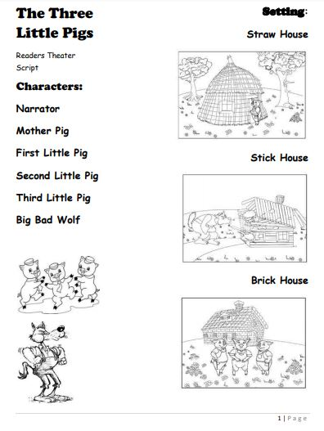
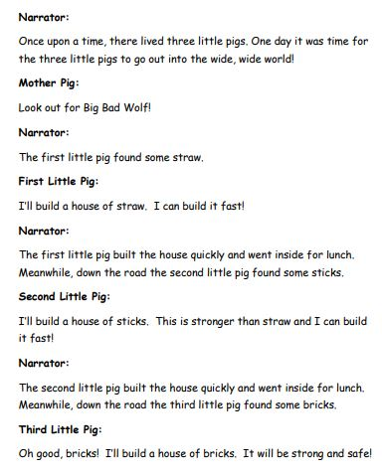

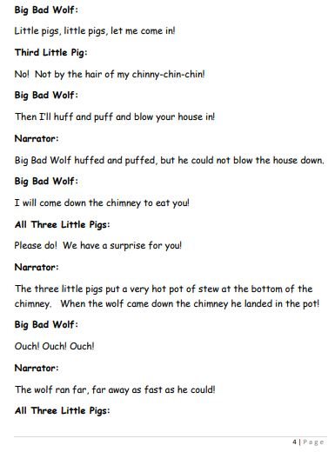
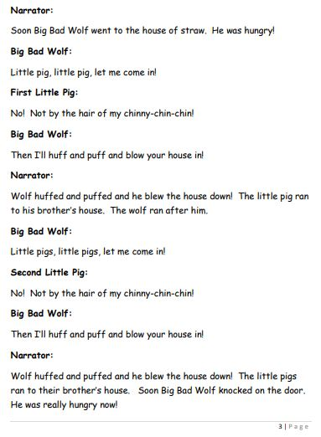

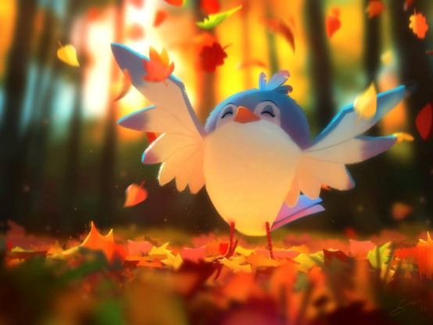
FRIDAY – WRITING

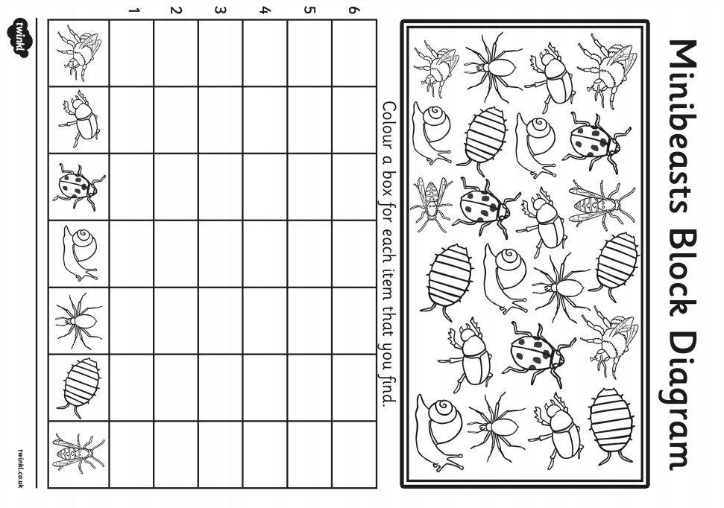
FRIDAY – MATHS

FRIDAY - PE
