Stage 2 Learning Framework Week 5
If you have any issues please contact you teacher via Class Dojo. Work can be completed in your homework book, digitally or on paper.
If you finish an activity early don’t forget that there are lots of tasks to do on Reading Eggs and Essential Assessment.
 | Monday | Tuesday | Wednesday | Thursday | Friday
Morning | English  Read one chapter of a book on reading eggs or a book that you have at home.  Draw a family tree, detailing who is part of your family. Remember not all your family members have to be blood relatives. Every family looks different.  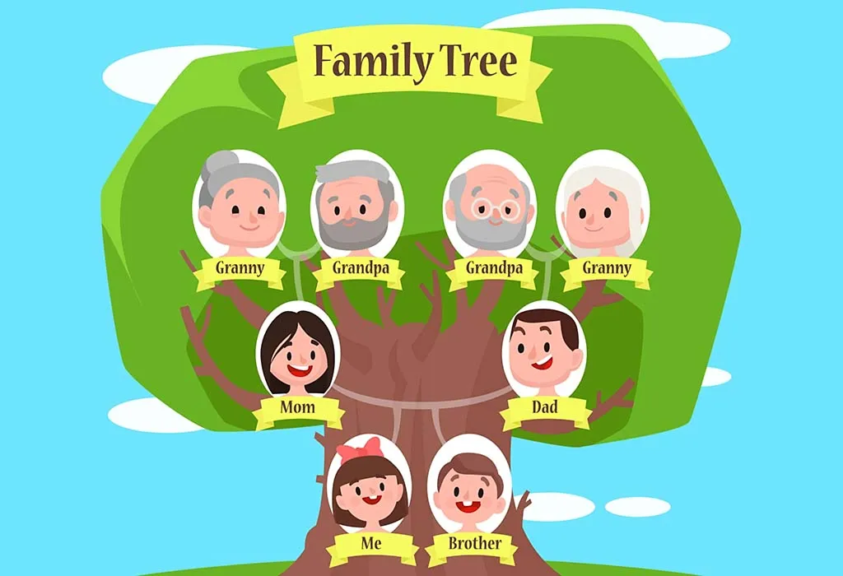 | English  Read one chapter of a book on reading eggs or a book that you have at home.  Create at least 2 descriptive paragraphs using sizzling starts, describing a time you did something fun with your favourite family member. Remember you need at least 5 sentences. | English  Read one chapter of a book on reading eggs or a book that you have at home.  Use your six senses, Touch, taste, feel, smell, see and emotions to describe your favourite memory with your family. Write at least 2 paragraphs. | English  Read one chapter of a book on reading eggs or a book that you have at home.  Ask your family members what their favourite saying or quote may be and why. Write down their response in your book.  What is your favourite saying or quote? Write it down in your book and tell us why it is your favourite | English  Read one chapter of a book on reading eggs or a book that you have at home.  Guess who?  Without saying how the person is related to you write a detailed description using some of your 6 senses to describe somebody in your family. Don’t forget to use their quote from yesterday too!
Break
Middle | Mathematics  Practise your 1 and 2 Division facts. Write them in your workbook eg: 1 divided by 1 =  Angles  Use the hands of an analogue clock to form angles. Right angles are 90 degrees.  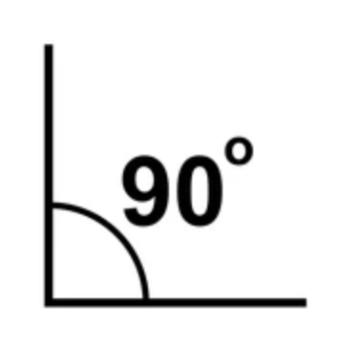  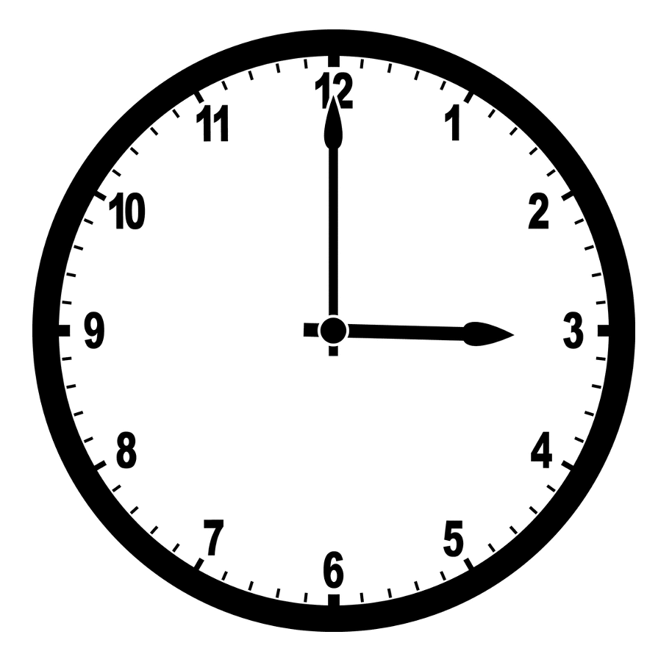  e.g. 3 o’clock = a right angle (90 degrees)  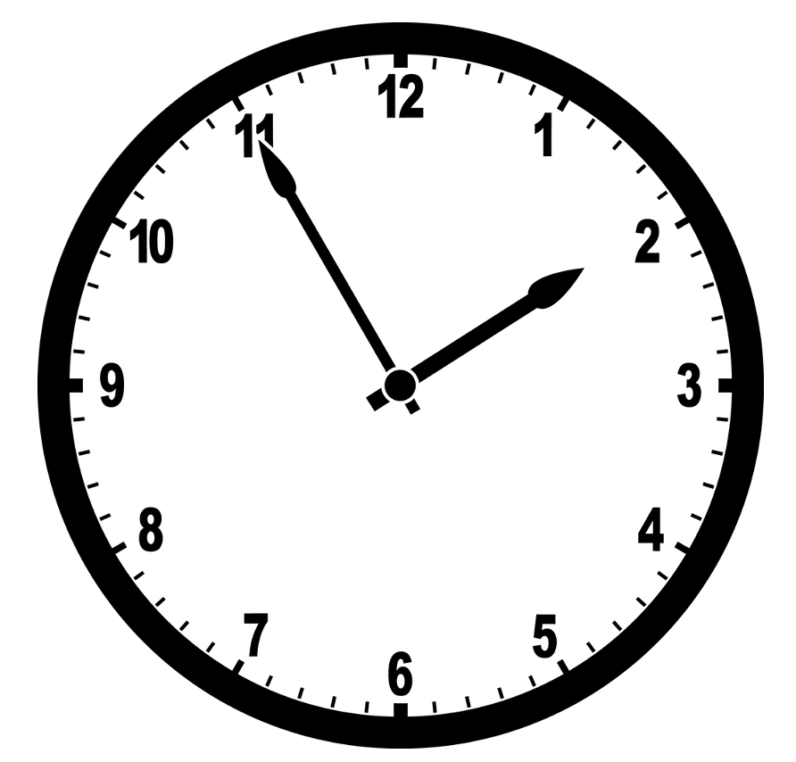  e.g. 1:55 = a right angle (90 degrees)  How many right angles can you form?  Can you see a trick using the numbers on the clock face to easily make a right angle? | Mathematics  Practise your 8 and 10 Division facts. Write them in your workbook  Angles  We call smaller angles acute angles (less than 90 degrees). They are angles smaller than a right angle.  We call large angles obtuse angles (more than 90 degrees). These are angles that are larger than a right angle.  Can you think of any shapes that have acute angles?  Can you think of any shapes that have obtuse angles?  Draw and label your shapes in your book. | Mathematics  Practice your 3 and 9 Division facts. Write them in your workbook  Angles  Find right angles around your house. How many can you see? Draw and label these examples in your workbook.  Can you find any acute or obtuse angles around your home? Draw and label your answer. | Mathematics  Practice your 11 and 12 Division facts. Write them in your workbook  Patterns and Algebra  Skip count by 4s, 6s and 9s. Write them in your workbook.  Angus cuts out a shape. He folds it in half. It is symmetrical. Draw what Angus’s shape might look like.  Make you own repeating pattern in which the 6th shape in the pattern is a Red Circle.  This pattern grows by 1 each time. Draw your own pattern that grows by 2.  Sam has a piece of string that measures 26 centimetres. He’s finds something at home that the string fits round exactly. Use your own string to find out what this could be.  Draw pictures of what you find. | Mathematics  Practise your 5, 6 and 7 Division facts. Write them in your workbook  Patterns and Algebra  Skip count by 3s, 7s and 8s. Write them in your workbook.  Create a table in your workbook with the headings Odd and Even. Under each heading put these numbers based on being odd or even numbers: 24, 66, 168, 137, 289, 572, 1830, 2933, 7429, 2997, 4623, 2792.  Odd Even  Prove your understanding: Show 3 examples to show your understanding to the statement:  'An odd number added to an even number always results in an odd number’  Write them in your workbook.
Break
Afternoon | Creative arts  Drama  Watch a show or read a story. Look at how the main character acts. Draw a storyboard (comic) of what you watched/ read. | Science & Technology  Earth's Surface  Describe what you think the Earth's surface means.  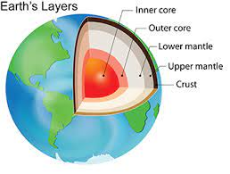Look at the picture and write a sentence describing the Earth's crust. Use the word bank to assist you.  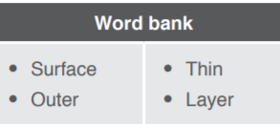 | Geography  Koala’s and humans both rely on their environment to live and survive.  Make a Venn diagram comparing the similarities and differences between how Koala’s and humans rely on their natural environment.  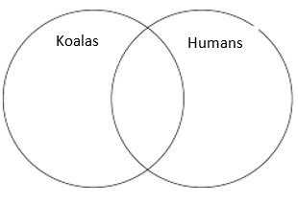 | STEM  Create a model of the Earth's layers. You can use anything you have at home. | Physical Activity  Animal walk: move around the house like a snake, bird, bear and a rabbit.  Dance: Put on your favourite music for 20 mins and dance.  Chores: Help a family member with chores around the house for example help vacuum the house, mop the floors, pick up toys or do the dishes.  Safety  Create a poster on how we can be sun safe.  