Stage 3: working from home activities, Week 5
Please complete the following work while at home.
If you do have access to a device, please ensure that you are logging on to Reading Eggspress and Sunset Maths daily. Don’t forget to share pictures of your work with your class teacher in Dojo. You can add the work to your portfolio or send it in Dojo messenger. Please ensure that you share this work daily. Don’t forget that you have access to thousands of educational clips in your clickview account by using your school computer login. Remember that you should be reading at least 30 mins each and every day and learning/memorising all of your times tables up to 10x.
 | Monday | Tuesday |  | Wednesday |  | Thursday |  | Friday
Morning | English  What is your dream job? Write a persuasive text explaining why the job you chose is the best career option for you. Include opinions, persuasive phrases, and facts in your text.  Create a list of words that contain the Latin roots script or scrib, e.g. prescription, scribble.  Try to think of at least 10 words. Explain each word to an adult and tell them why it contains the Latin root.  Remember that reading eggs has plenty of books to read in the library. Choose a chapter book as you will need it for the entire week. | English  Select one or more of the large words from the list and find as many smaller words within them. The words can be made by shuffling around the letters.  jurisdiction sustainability  collection generation  maintain auditorium  Choose a type of poem e.g Cinquain or Acrostic to write one of your own. Choose your own word, a different word, to start with e.g. Chocolate, winter, cold, your own name, a pet’s name. Try to think of interesting adjectives (words that describe nouns,e.g the jumpy frog,’ jumpy’ being the adjective). In the Cinquain, a synonym is used (synonym: means ‘the same as’ e.g ‘shut’ is similar to ‘close’. When you finish, draw a picture to go with it. Send it to your teacher. |  | English  Reading and visualising:  Read one chapter of a chapter book. Using show don’t tell describe the setting. Make sure to describe the sights or scenery, the sounds and smell.  Spelling:  List 10 unfamiliar words from your book and write them in alphabetical order. Extension: find the meaning or definition for each word.  Writing:  Haiku’s originate from Japan, which generally focus on nature. A form of poetry which is written with few words to capture a moment and create a picture in the readers head.  Write a Haiku Poem about a chosen topic. If you are uncertain about what a Haiku is research for clarification and examples (example of poem is provided) Line 1: 5 syllables Line 2: 7 syllables Line 3: 5 syllables |  | English  Use your English task from last Thursday about ‘learning at home is the best’. From the arguments you brainstormed choose if you are for or against the topic. Write your introduction and body paragraphs for your argument.  Some helpful tips:  Introduction  - Choose a sizzling start from last week to write your introduction  - Your introduction should also address what your opinion is clearly about the topic: learning at home is the best!  Body Paragraphs  - Your paragraphs should be written in this order: strong, medium and strongest argument.  - Use persuasive techniques to engage the reader e.g direct speech, emotive language etc.  - Use tightening tension in your strongest paragraph  Remember to keep your writing for next week’s task. |  | English  Write a definition of what poetry is.  What is a syllable? Using a dictionary, write a definition. Write a list of 5 one syllable words (e.g. on, go), 5 two syllable words (e.g. eating, chicken) and 5 three syllable words (e.g. worrying, crocodile). Clapping your hands as you say a word will help to work out the number of syllables.  A Haiku is a Japanese poem of seventeen syllables, in three lines of five, seven, and five, traditionally about the national world.  Here is an example;  A sunlit forest,  The endless sounds of chopping  Busy parking lot.  Use the following link to look at some more examples of Haikus if you would like to; https://examples.yourdictionary.com/examples-of-haiku-poems.html  Write your own Haiku about nature. Remember to check the number of syllables in each line.
Break
Middle | Mathematics  Place a plastic bowl on the floor. Standing 10 steps away, toss a cotton ball in the bowl 25 times. How many made it in? Write the number as a fraction, decimal and percent. Repeat the game, tossing the cotton ball 15 times.  Measure your foot in centimetres. Convert it to metres and kilometres. If a football field is 100 metres long, how many of your feet will it take to get from one end of the field to the other?  On average, 4 babies are born every second world-wide. How many babies are born every 10 minutes? |  | Mathematics  If the answer is 256, what could the question be? Write at least 5 options.  3 4 9 7  What is the largest number you can make using the numbers below? Don’t forget to use multiplication!  Estimate how many pencils you think would be in your classroom. Think about how many students are in your class, how many each of them may have and how many your teacher might be hiding in their storeroom and desk! Explain your working out. |  | Mathematics  Mass:  Students brainstorm different units of recording mass. Then complete the table (This is attached).  Treasure hunt:  Find items in or around the house that weigh approximately 1 kilogram.  Students record items which are estimated to be 1 kilogram. If you do not have scales to check the weight, have a look in the cupboards and around the house sometimes you can find items that may be labelled already like 1kg flour or 1kg sugar. Use that to compare the weight of another item in the house.  Then measure and record the mass as 1 kilogram.  Create another list for objects that weigh more than 1kg (If scales are not available to record the mass make sure to estimate the actual weight).  Then create one last list for objects that weigh less than 1kg.  Each list should have a minimum of 10 objects.  Extension: Explain how a balance scale works, include illustrations, labels, notes or diagrams to support you explanation. |  | Mathematics  Vowels are worth $50 and consonants are worth $40. Can you make a word that is worth $280? How about $620? How much is your name worth?  Add to 100  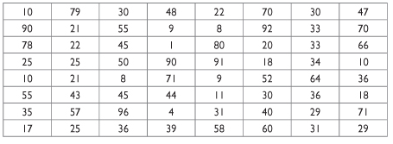  Use the grid attached or draw your own with the same numbers.  Find all the groups of two or three numbers, side by side, across or down, which can be added together to equal 100. Colour these groups, using a different colour for each group.  Take a picture and write down what mental strategy you used: eg. adding tens first and then ones |  | Mathematics  If Jade does a good deed for three people and those three people each do a good deed for three different people. How many people would have a good deed done for them based on the above information? Please show your working out.  Plan a day out for when lockdown ends. Write down a schedule for your first day out, make sure to write times and a brief description e.g. 9am Milkshake at Westfield 10am Shopping with friends 12pm Lunch at Grandmas
Break
Afternoon | Geography  Saving Water  - List some of the ways you could save water at school.  - Explain why it is important to conserve water.  - Create your own saving water campaign slogan.  - Make a poster for your slogan to promote saving water at school. |  | Science and technology  Write down what you know about our Solar System. What planets do you know? Do you know which planet is closest to Earth? Draw what you think each planet looks like. If you have access to a computer, list 3 interesting facts about each planet.  Estimate how far you many kilometres you think Earth is from the Sun. |  | PE  Balancing act:  Players balance various objects to see which shapes are easiest to balance. These various objects could include a racquet, bat, book, plastic plate, spoon.  Players modify the game by using different body parts to balance the objects.  Time and record how long the object can be balanced on different body parts:  Hand:  Knee:  Foot:  Elbow:  Chin:  Make sure to look out for others when balancing items.  Extension: Video record yourself walking while completing the balancing act.  Or start standing, then lay down on the ground and then back up all whilst balancing the object.  ‘Jump’ the balancing object from one body part to another  Reflection:  What objects balance the best, or the worst?  What strategies did you use when you found it challenging (e.g. positive self-talk)?  What can affect your focus in this activity? |  | Geography  The Tokyo 2020 Olympic mascot is styled with the Ai (indigo blue) Ichimatsu pattern from the Tokyo 2020 Games emblem, a tribute to both the respected tradition and modern innovation of Japanese culture.  In 2032, Brisbane will be hosting the Olympics  - Create a mascot using Australian Fauna and Flora.  - Give the mascot a name  Write a short paragraph about what the mascot represents. |  | Creative arts  Using a mirror to help you, draw a cubist-inspired self-portrait.  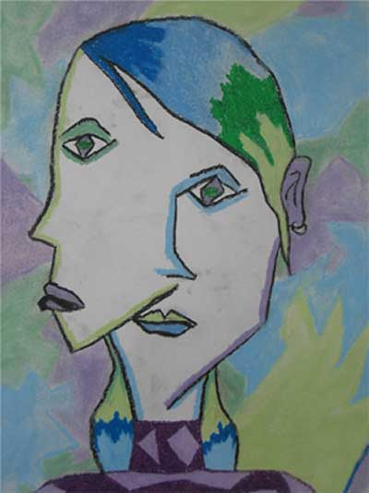  Sketch an impression of your face from two viewpoints (profile and frontal view) on each half of a page. The two viewpoints meet or overlap in the centre of the page. Try to use shapes for some facial features.

