Stage 3: working from home activities, Week 6
Please complete the following work while at home.
If you do have access to a device, please ensure that you are logging on to Reading Eggspress and Sunset Maths daily. Don’t forget to share pictures of your work with your class teacher in Dojo. You can add the work to your portfolio or send it in Dojo messenger. Please ensure that you share this work daily. Don’t forget that you have access to thousands of educational clips in your clickview account by using your school computer login. Remember that you should be reading at least 30 mins each and every day and learning/memorising all of your times tables up to 10x.
 | Monday | Tuesday |  | Wednesday |  | Thursday |  | Friday
Morning | English  Compound Words – A compound word is made up of two different words. Each word can stand by itself with its own meaning. The compound word creates a new meaning.  e.g. sand + paper= sandpaper  Write 10 compound words.  Persuasive Writing-  Choose whether you are ‘for’ or ‘against’ the following statement.  ‘All Families Should Own a Pet’  Structure your work using your seven-step techniques.  Remember that reading eggs has plenty of books to read in the library. Choose a chapter book as you will need it for the entire week. | English  1. Word of the day -‘Bewildered’  Look up the definition of the word ‘bewildered’ and use it in a sentence.  2. Sentence challenge  Write 2 sentences using speech marks.  E.g. “Stop! You’re going too far!” yelled Jacob.  3. Paragraph Practice  Use the following picture prompt to write a descriptive paragraph:  Your paragraph needs to have:  - a topic sentence & closing sentence  - noun groups (adjective + nouns)  - Speech marks – at least 1 person speaking. |  | English  Reading, visualising and writing  Choose a book or article to read. Read for 15-20 minutes then:  1.Select 2-3 sentences  2.Make a picture of the sentences in your mind  3. Draw the picture using only pencil, the pictures need to be explicit they do not need to be works of art.  4. Describe the picture using the cue “In my mind I see..”  Tip: Be descriptive, make sure to use figurative language.  Spelling  From the book you read select 10 random words and write some synonyms for them. Synonyms are words that have similar meanings. Then using your selected random words write the silliest story you can think of. |  | English  Continuing with Learning at home writing is the best!  Last week you would’ve written your body paragraphs. Today you will be working on tightening tension and dynamic dialogue.  Strongest (last body paragraph -Tightening Tension  Re-read your last body paragraph and check that you have included tightening tension. Different techniques you can include are:  - Rule of three  - Repetition  - Rhetorical question  - Emotive language  Dynamic Dialogue  People believe, real people’s words. Using the arguments, you have written down in your body paragraphs. Find some information on your argument. Here you can get direct quotes from a researcher, professional or eyewitness. Then add those quotes to the appropriate places in your paragraphs.  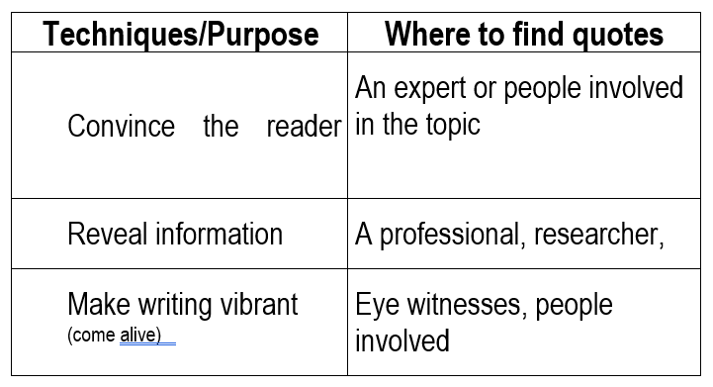  REMEMBER TO KEEP YOUR WRITING FOR NEXT WEEK! |  | English  Write about the person you want to see at the end of lockdown. Describe them and say what you like about them. Write about what you miss about them, and what you are looking forward to doing with them when you are next together. You could draw a picture of them wearing something you remember them in.
Break
Middle | Mathematics  Multiply the following using the double, double, double strategy.  Tip- When you multiply any number with 4, double it twice, and when you multiply it with 8 double it three times (double, double, double).  For example- 12×4 =  Steps:  Double 12 is 24, and double 24 again 48.  The answer is 48.  12 × 8 = 96  Steps:  Double 12 is 24, double 24 is 48, and double 48 is 96  16 × 4 =  14 × 4 =  22 × 8 =  32 × 8 =  50 × 8 =  116 × 8 =  Word Problem:  It is 8.30 am. Kim is waiting for the 10.45 am bus. Buses arrive every 15 minutes. How many buses will Kim see before she leaves?  Challenge-  Jennie the old sheep dog is lazing around in the paddock near the house. She counts the number of animals in the paddock. There are 11 of them, pigs and ducks. Then she counts the legs. She sees 28 legs. Show your working out.  How many ducks are there? |  | Mathematics  Warm up  Convert the following into grams:  2kg 3.75 kg 1.873kg  9.09 kg 5.609kg 3.404kg  Word Problems  1. A package that is heavier than 12.5 kg will have a label that says “heavy” on it. Gloria packed 6 flower pots to send to her customers. Each of the flower pots weighs 1.5kg. The packing material weighs 0.5 kg. Will her package be labelled as “heavy”?  Show your working out.  2. A packing box can hold up to 11kg. If Jack puts in 5 shirts weighing 500g each and 3 pairs of shoes weighing 1.4 kg each, how much more weight can Jack put in the packing box?  Your turn  If the answer is 895 grams, what could the word problem be? |  | Mathematics  Warm up: The answer is 74 what is the question? Try to come up with a range of question that require multiple operations.  Task: Plan your own FUN day. You have $350 to spend and you can go anywhere within the day. Where will you go?  What will you do?  Will you eat lunch?  Will you take a friend?  Go to Starbucks?  The things you could do and the places you could go!  Use a table like the one below to record your expenditures (costs).  Activity cost quantity total  Breakfast  Lunch  Raging waters  Movie  Dinner  Did you have any change and how much was it?  Extension: It was your lucky day and there was a 25% discount on every item or activity paid for. What was the cost of each individual item and your final cost for the day?  What is the amount of change you would receive from the $350 |  | Mathematics  Word problem of the day  The total weight of Tania’s bag is 45.75 kg and Diana’s bag is 43.95 kg. Whose bag is heavier and by how much?  Estimation  When we estimate we are trying to get as close to what we think the answer will be without doing any formal working out.  Complete the table below  Sum After rounding Estimate  e.g. 689 + 405 = 700 + 400 1100  a) 498 + 201 =  b) 807 + 905 =  c) 1212 + 3497 =  d) 4291 + 6411 =  e) 214 + 499 + 302 =  f) 587 + 314 + 795 =  Extension  Check how close you were with your estimations by working out the correct answer. |  | Mathematics  Measurement  Make a list of 5 things which can be measured in mm, cm and m.  Choose 10 things around the house to measure. First, predict which one you think will be the longest/shortest. Then predict what their total length will be. Next, use a ruler to measure each item (if you don’t have a ruler, use an object such as a coin to measure). Finally, round each measurement to the nearest 10. Remember to add your units – are you measuring in mm, cm or m?
Break
Afternoon | Geography  Class Flag- A flag is an emblem that represents a group of people, their history and their ideals.  Design a flag for your class. What things do you think it is important to represent? |  | Science and technology  Investigation – sink/float  Density - a measurement that compares the amount of matter an object has to its volume. An object with much matter in a certain volume has high density.  Buoyancy - a force on an object making that object rise or move upward.  Gather 10 items from around the house (ask your parents if its okay to get them wet). Fill a container with water. Predict whether each one of your 10 items would sink or float. Record your results in table like the following:  Object Prediction (sink/float) Sink Float  Spoon Sink? ✅  Hair tie Float? ✅  Lego Sink? ✅  Look at the objects that sank. What do they have in common?  Look at the objects that floated. What do they have in common? |  | PE  Fitness Bingo!  Using the Fitness Bingo activity sheet complete as many of the activities as you can. Mark off each one as you go.  4 right leg lunges 2 grape vines Row on the spot for 30 seconds  10 scissors Free choice March on the spot for 30 seconds  12 star jumps Sprint on the spot for 30 seconds Side to side step for 30 seconds  Extension: Time yourself and see how long it takes to complete all activities.  Can you complete it a second time and improve your original time? |  | Geography  You are a voyager  Choose a country to explore. If you have access to a computer and the internet use Google Earth, if not think of a place you have been to (it can be Australia)  When you are exploring your country take notes of the following information: biome (forest, desert, rainforest etc), flora and fauna, landforms, sky line, major attractions. Place the information together with drawings of the physical geography.  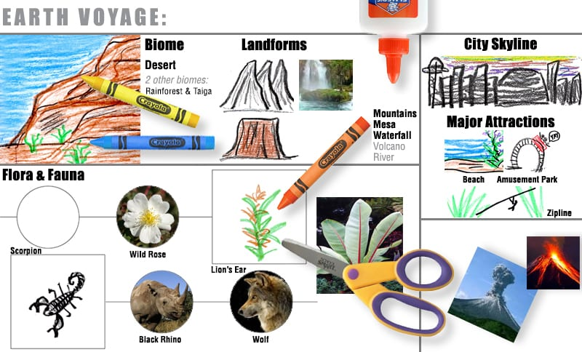  Below is a sample of how you can set out your work: |  | Creative arts  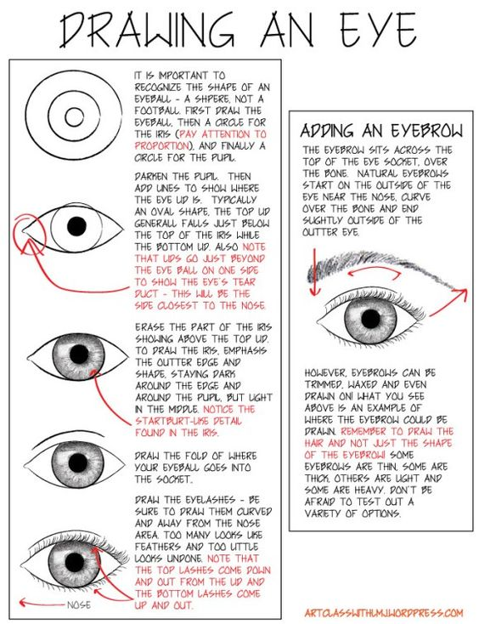  On a blank piece of paper draw an eye using the above step-by-step guide to help you. Make sure that you use pencil and focus on your shading.  Critical reflect on your artwork. Answer the following questions; what did you learn during this task?, what would you change for next time?

