Blacktown City Council Trees
Dear Parents and Caregivers

If you are a resident in the Blacktown City Council area you are entitled to claim 2 trees each financial year to plant in your yard. We are asking that if you do not intend to claim the trees for yourself that you consider completing the form in this letter which will allow the school to claim these trees on your behalf. These trees will then be planted in the grounds to provide shade and entice birdlife over the coming years.

Please complete and return the form to the front office by the end of May. We will then visit the council nursery and select plants for other areas of our school which will complement the trees already donated in the past three years along the front pathways near the office, the library and the walkway near the Stage 1 demountables.

Our photographs demonstrate the difference you can make!
2010 2012 2014
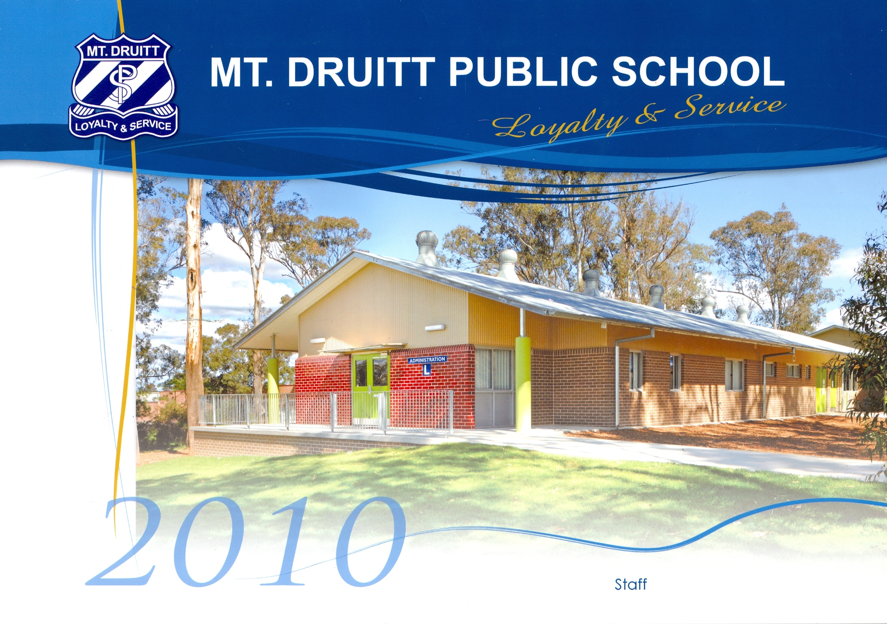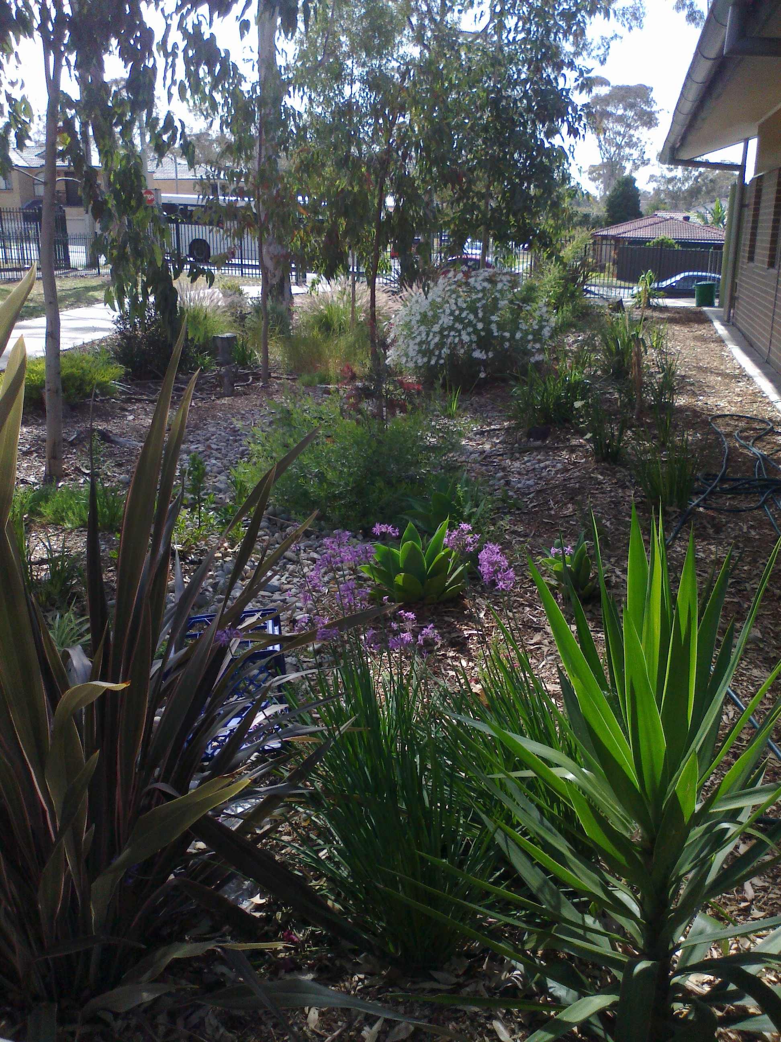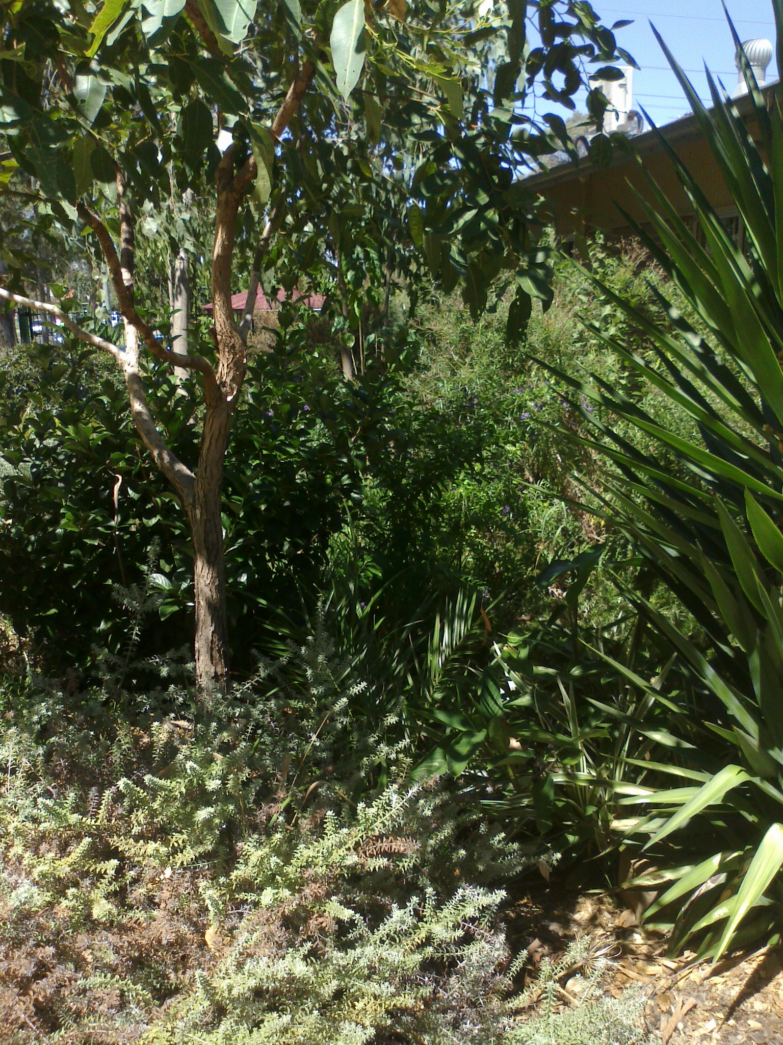
On behalf of the students and staff, thank you for your generosity
A Cameron
Deputy Principal
Blacktown City Council Trees Reply Slip: Please return to the school office by 1 April 2015.
I/We are residents of Blacktown City Council and would like to donate our 2 free trees to Mount Druitt Public School.
Our residential address is
(Please print)__________________________________________________________________
_________________________________ ____________________________ ___________________
Name/s (please Print) Signature Date

