

***Mount Druitt Public School***

Belmore Avenue, Mt. Druitt, N.S.W.

Telephone: 9625 9036 Facsimile: 9832 2453

EMAIL: mtdruitt-p.admin@det.nsw.edu.au

Dear Parents/Caregivers,

Welcome to the new school year. This year the stage one teachers are:

* Miss Harsh- (Stage Supervisor)
* Mrs Smith- 1/2L (Stage Supervisor)
* Ms Caves- 1/2C
* Mr Foxwell- 1/2F
* Mrs Sohal- 1/2S
* Mrs Toomey- 1/2T
* Miss Vikash- 1/2V
* Mrs Ali- 1/2A
* Miss Shalala- Junior MAC

If you haven’t already met your child’s class teacher, please introduce yourself and say hello. We are looking forward to being a part of your child’s education this year and welcome the opportunity to work in partnership with you to provide a solid and stimulating educational program for your child.

**Supplies**

[](http://www.google.com.au/url?sa=i&rct=j&q=&esrc=s&source=images&cd=&cad=rja&uact=8&ved=0CAcQjRw&url=http://www.racketboy.com/forum/viewtopic.php?p%3D501002&ei=sUHYVPH7ONOA8gX6-YJI&bvm=bv.85464276,d.dGc&psig=AFQjCNE1QKo8rH6dT6EOVywyNOLGgPYz0A&ust=1423545108055397)The following is a list of supplies that we kindly request for you to send to school with your child. Your child will give the supplies to the class teacher who will distribute for whole class use.

* 2 HB lead pencils
* 2 erasers
* 2 sharpeners
* [](http://www.google.com.au/url?sa=i&rct=j&q=&esrc=s&source=images&cd=&cad=rja&uact=8&ved=0CAcQjRw&url=http://www.jerrysartarama.com/discount-art-supplies/pencil-sharpeners/kum-pencil-sharpeners/artists.htm&ei=SELYVJe6BouJ8QXK-YDAAg&bvm=bv.85464276,d.dGc&psig=AFQjCNGQ3UVqtr3u1R1B-esqRlhj3ulfBQ&ust=1423545259617494)[](http://www.google.com.au/url?sa=i&rct=j&q=&esrc=s&source=images&cd=&cad=rja&uact=8&ved=0CAcQjRw&url=http://quoteimg.com/baby-wipes/&ei=ikPYVOiTOpGB8QXai4HIAg&bvm=bv.85464276,d.dGc&psig=AFQjCNFTKDXNB_2f2l5HVUHR5w69nHJzGA&ust=1423545555513495)2 large glue sticks
* 2 boxes of tissues
* Container of Baby Wipes
* 2 Hand washes
* [](http://www.google.com.au/url?sa=i&rct=j&q=&esrc=s&source=images&cd=&cad=rja&uact=8&ved=0CAcQjRw&url=http://www.alextoys.com/product/2-chunky-glue-sticks/&ei=tELYVNmSHovi8gXHr4GAAg&bvm=bv.85464276,d.dGc&psig=AFQjCNFgn9aBZRUQBkY6W1RAMFyiO2qZGA&ust=1423545347597598)2 rolls of paper towel

[](http://www.google.com.au/url?sa=i&rct=j&q=&esrc=s&source=images&cd=&cad=rja&uact=8&ved=0CAcQjRw&url=http://www2.woolworthsonline.com.au/Shop/ProductDetails?Stockcode%3D19787&ei=SETYVLj2LMuA8gWL7oBw&bvm=bv.85464276,d.dGc&psig=AFQjCNHQV1E7uogmvi3i_lDDaaGjV2Aurw&ust=1423545723358325)[](http://www.google.com.au/url?sa=i&rct=j&q=&esrc=s&source=images&cd=&cad=rja&uact=8&ved=0CAcQjRw&url=http://www.thehealthcounter.com/view/all/toiletries/hand-wash-soap/&ei=ykPYVI7dCsmk8AWgxoDgAQ&bvm=bv.85464276,d.dGc&psig=AFQjCNF307qNcGeQjz1gPW2YO5eNmd15Cg&ust=1423545653275535)[](http://www.google.com.au/url?sa=i&rct=j&q=&esrc=s&source=images&cd=&cad=rja&uact=8&ved=0CAcQjRw&url=http://www.officeworks.com.au/shop/officeworks/kleenex-2-ply-facial-tissues-200-sheet-box-ki04715&ei=J0PYVN3cOoj18QWf54DgCw&bvm=bv.85464276,d.dGc&psig=AFQjCNE1ZfrAHfscfpYmj3pzsUF2nUW69g&ust=1423545464967367)

**Open Door Policy & Parent Helpers**

At Mount Druitt P.S. we have an open door policy and promote free communication. Parents and carers are always encouraged to communicate with class teachers and members of the school executive team and the principal. Helping out at school is a great way to get involved in your child's education and to get to know the school staff and other parents. Research shows that children benefit when their parents are actively involved in their education and school life.

[](http://www.google.com.au/url?sa=i&rct=j&q=&esrc=s&source=images&cd=&ved=0CAcQjRw&url=http://www.kaskus.co.id/thread/533d0bb582cf17517400005d/lounge-anak-pariwisata-perhotelan-se-indonesia--all-about-tourism&ei=ZkXYVKPLDonz8QX33IJQ&bvm=bv.85464276,d.dGc&psig=AFQjCNFAL_9EX-fXt6YBieMMIjxZgxwsag&ust=1423546028211328)Keep an eye on the school newsletter for opportunities to help out at school and ask your child's teacher if you are interested in helping in the classroom.

Here are some ways you can help:

* listen to children read in the classroom
* volunteer on sports days
* help to supervise excursions
* get involved in fundraising activities join a school committee.

**Teacher’s Professional Learning**

MDPS staff are committed to professional Learning. As teachers, we are required to attend Professional Learning to ensure we are meeting the learning needs of our students. While we try to ensure our professional Learning takes place out of school hours, we sometimes need to attend during school hours.

Please be assured that when the teacher is off class, that they have prepared lessons for the relieving teacher to complete. This ensures that the teaching program is uninterrupted. Should you have any further question regarding professional learning, lease see your class teacher.

[](http://www.google.com.au/url?sa=i&rct=j&q=&esrc=s&source=images&cd=&cad=rja&uact=8&ved=0CAcQjRw&url=http://www.blendedmec.com/special-guests/guest-blogs/practical-information-about-e-learning-recruitment-and-training&ei=yUXYVK-iN8XZ8gWLxYCAAQ&psig=AFQjCNGgyDjDgdJNp5ep6yLQkU1O4N07DQ&ust=1423546175294609)

**Attendance**

[](http://www.google.com.au/url?sa=i&rct=j&q=&esrc=s&source=images&cd=&cad=rja&uact=8&ved=0CAcQjRw&url=http://www.clipartpanda.com/categories/prevalence-clipart&ei=KUbYVMrSAo7o8AWCl4DYAg&psig=AFQjCNFYNhPmqBYvr9QYu9kUWdUD0UR2Ng&ust=1423546259721942)Your child’s attendance and punctuality to school is very important. Being on time to school and having high attendance not only ensures the student benefits from instruction but will also set patterns for their lives as adults in the workforce. If your child is away from school for any reason, the parent/caregiver needs to **write** an explanation for the absence the day of return to school. Please note that an acceptable absence should be due only to sickness or leave.

**Healthy lunch box ideas**

Eating healthy food helps children concentrate and learn. Therefore it is very important to pack a balanced lunch to ensure they’re getting the nutrients they need.

An easy way to ensure that your child is getting the nutrients they need follow the “fill it with 5” guide:

1. Fresh fruit
2. Crunchy vegetables
3. A meat or protein food such as slices of lean meat, hardboiled egg, peanut butter or nut paste*
4. Dairy food such as a cheese stick or slice, grated cheese, milk or yoghurt
5. 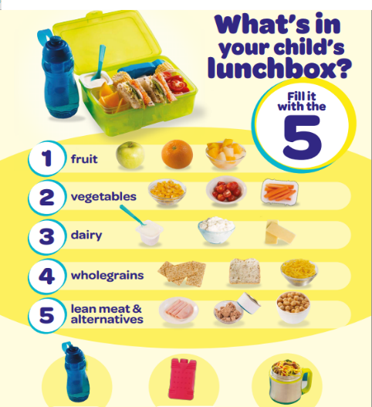Starchy food such as bread, a roll, pita or flat bread, fruit bread or crackers
6. Water.

[www.eatforhealth.gov.au](http://www.eatforhealth.gov.au)



**Crunch&Sip®**

Our school is committed to improving children’s health through education and by supporting the Australian Government’s Crunch&Sip® initiative.

Crunch&Sip® is a set break for students to eat fruit or salad vegetables and drink water in the classroom.

We encourage you to support your child to participate in Crunch&Sip® by providing a **clean water bottle** and a **piece of fruit or vegetable** each day.

Research has shown that drinking water and eating fruit and vegetables is essential for good health and can help concentration throughout the day.

<http://www.crunchandsip.com.au/>

**PBL**

At MDPS we are responsible respectful l earners (RRL). These guidelines are reinforced daily in classrooms and on the playground. Students will be rewarded for displaying these behaviours in the classroom through receiving their RRL wristbands. You can help your child be a responsible respectful learner by having them at school at 9am and in full school uniform.

**Library Times**

Each class will attend a weekly library session as part of their learning program. Please note the day and time that your child’s class will attend library each week.

|  |  |  |  |
| --- | --- | --- | --- |
| **Class** | **Teacher** | **Day** | **Time** |
| 1/2F | Mr Foxwell | Monday | 11:45am – 12:15pm |
| 1/2L | Mrs Smith | Monday | 2:00 – 3:00pm |
| 1/2S | Mrs Sohal | Tuesday | 12:45 – 1:30pm |
| 1/2V | Miss Vikash | Wednesday | 11:45 – 12:15pm |
| 1/2T | Mrs Toomey | Tuesday | 2:00 – 3:00pm |
| Junior MAC | Miss Shalala | Thursday | 9:00 – 11:00am |
| 1/2C | Ms Caves | Thursday | 11:45 – 12:15pm |
| 1/2A | Mrs Ali | Thursday | 2:00 – 2:30pm |

[](http://www.google.com.au/url?sa=i&rct=j&q=&esrc=s&source=images&cd=&cad=rja&uact=8&ved=0CAcQjRw&url=http://www.dreamstime.com/royalty-free-stock-photos-smiling-young-girl-reading-front-bookshelves-illustration-white-background-image32330898&ei=N0fYVMCuCs3m8AWU4IHoAg&psig=AFQjCNHyU9rpI92AepP4zSdBH0mAhPhZ2Q&ust=1423546529114532)1/2L and 1/2T will take their school bags to the library with them, and will leave school from there. Please meet your child at the library after their library session on their days. Junior MAC will go straight to the library on Thursday mornings, with their school bags.

**Homework**

Homework at MDPS has changed over the past few years. Formal homework will not be given to students. Instead we encourage parents and students to work together at home doing a variety of household chores and tasks such as shopping and cooking.

We also encourage students to visit the home reading room daily (8.30-8.55am) and spend time reading each night. For writing, having your child write about their school day in a notebook would be an excellent way to practise skills taught in class.

[](http://www.google.com.au/url?sa=i&rct=j&q=&esrc=s&source=images&cd=&cad=rja&uact=8&ved=0CAcQjRw&url=http://www.carehouse.org.nz/viewpage.php?page_id%3D30&ei=hkfYVLLcG5WD8gXag4G4Ag&psig=AFQjCNHerQ72W3PDUZjb5K7JEnUi2gB3zg&ust=1423546619282911)

**Steps to success with home reading**

1. Choose the right environment
2. Make sure the child is ready to read (not tired)
3. Set the scene – Discuss title, cover, pictures and predict what the story may be about
4. During reading – talk about the story so far and try to predict what will happen next

|  |
| --- |
| **On finding an unknown word:**   * **Pause** -to give child time to work out word * **Prompt**  -to go back to the beginning of the sentence   -read past the unknown word  -look for a clue in the picture  -look at the first letter & think about what it could be  -ask “Does this make sense?”  -try to sound out the word  -tell the child the word   * **Praise** -your child even if mistakes weremade |

1. Conclusion of reading

* Make positive comment about how well the child read
* Question student about storyline
* Discuss moral of the story
* Revisit the child’s favourite page

**Points to Consider**

* We want children to read for pleasure – don’t let them think it’s a chore!
* Comprehension of the storyline is more important than decoding!
* Be generous with praise
* Don’t force child to decode every unknown word, sometimes just tell them the word to keep the flow going
* Share the reading(1 page each) if child is becoming frustrated or tired
* Re-read the same up to 4 times so children experience success
* Make reading a very important part of your child’s day

**Other ways you can help improve your child’s reading**

Value reading in the home

* Always focus on comprehension.
* Have children see you read – novels, newspaper, recipes, lists, etc.
* Have a selection of quality texts, both fiction and non – fiction in your house.
* Visit your local library and borrow factual and fiction books.
* Give books as a special present.
* Label photographs with a sentence that the child supplies. Have these sentences on the fridge or wall for the child to read whenever they want.
* Write down words you know your child repeatedly makes error with and expose your child to them regularly.
* Increase your child’s vocabulary by using a wide range of words and explaining what difficult words mean.

**What to read?**

* Books from the school library
* Books from your local library
* Favourite stories over and over again
* Play “I spy....”
* Read the TV guide together
* Letterbox junk mail
* Write letters to Grandparents and cousins(hopefully they will reply)

**Uniforms**

At M.D.P.S we have a school uniform that we wear with pride. You can purchase uniforms and hats from our P&C uniform shop. Please make sure to send your child in full school uniform every day.

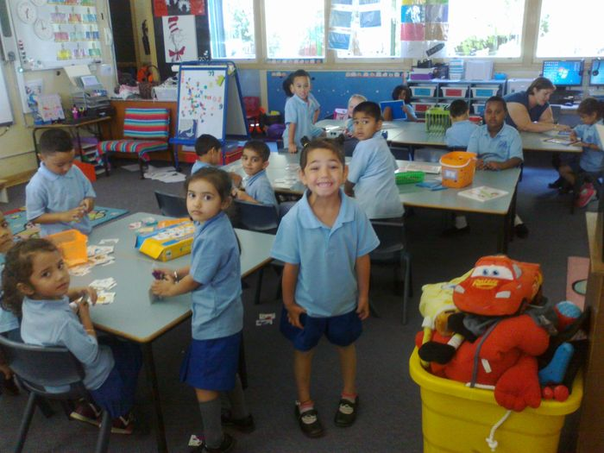[](javascript:void(0))

Should you have any questions or concerns regarding this Newsletter, please see your class teacher.

We look forward to an exciting year with you and your child/children.

Regards

*Stage One Team*